**How to Install rtabmap_ros in ROS Melodic??(Build from source)**

Install RTAB-Map standalone libraries:

|  |
| --- |
| cd ~ git clone https://github.com/introlab/rtabmap.git rtabmap cd rtabmap/build cmake .. [<---double dots included] make sudo make install |

Install RTAB-Map ros-pkg in your src folder of your Catkin workspace.

|  |
| --- |
| cd ~/catkin_ws/src git clone https://github.com/introlab/rtabmap_ros.git cd rtabmap_ros git checkout melodic-devel cd ~/catkin_ws catkin build |

**Reference:**[**link**](http://official-rtab-map-forum.67519.x6.nabble.com/apt-install-and-the-source-install-td1944.html)

The following reference reply is important .. can also try with this method (haven’t tried and verified).

Hi,

You can install ros-indigo-rtabmap and build rtabmap_ros from source. Make sure to use indigo-devel branch of rtabmap_ros. Just tried it and rtabmap_ros (indigo_devel branch) can be built without problems against ros-indigo-rtabmap binaries.

#make sure rtabmap_ros binaries are not installed

$ sudo apt-get remove ros-indigo-rtabmap-ros

$ sudo apt-get install ros-indigo-rtabmap

$ cd ~/catkin_ws/src

$ git clone https://github.com/introlab/rtabmap_ros.git

$ cd rtabmap_ros

$ git checkout indigo-devel

$ cd ~/catkin_ws

$ catkin_make

Make sure that there are no rtabmap libraries installed in "~/catkin_ws/devel/lib" or "/usr/local/lib", so that rtabmap_ros finds rtabmap installed in "/opt/ros/indigo/lib".

Cheers

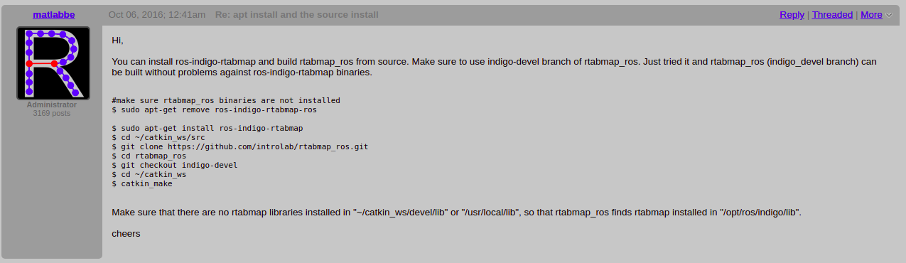

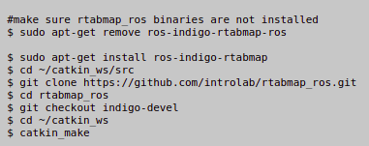

**How to use RtabMap with the turtlebot3 waffle model in simulation?**

**(Assumption: you already have rtabmap_ros package installed in the catkin_ws)**

RtabMap can only be used with turtlebot3 waffle model in simulation, as it only has RGBD camera i.e, Realsense R200. To use it with any other model we need to mount an RGBD camera to that model for use for any simulation/hardware.

**Step-1:**

Install turtlebot3 package from source (if you already have it you can skip this step):

|  |
| --- |
| cd ~/catkin_ws/src/ git clone -b melodic-devel https://github.com/ROBOTIS-GIT/turtlebot3.git  cd ~/catkin_ws && catkin_make |

**Step-2:**

Install turtlebot3_simulation package (if you already have it you can skip this step):

|  |
| --- |
| cd ~/catkin_ws/src/ git clone -b melodic-devel https://github.com/ROBOTIS-GIT/turtlebot3_simulations.git cd ~/catkin_ws && catkin_make |

Now, you must have 3 packages inside your catkin workspace:

**turtlebot3** , **turtlebot3_simulation** , **rtabmap_ros**

**Step-3:**

Download the following: [link](https://github.com/KenaHemnani/SemanticMaps/blob/master/RTAB_Map/turtlebot3_rtabmap.launch)

and copy into the following location:

**catkin_ws/src/turtlebot3/turtlebot3_slam/launch**

**Step 4:**

Download the following turtlebot3_rtabmap.rviz file: [link](https://github.com/KenaHemnani/SemanticMaps/blob/master/RTAB_Map/turtlebot3_rtabmap.rviz)

and copy into the following location:

**catkin_ws/src/turtlebot3/turtlebot3_slam/rviz**

**Step 5:**

Include the turtlebot3_rtabmap.launch and turtlebot3_rtabmap.rviz in turtlebot3_slam.launch:

(/catkin_ws/src/turtlebot3/turtlebot3_slam/launch)

Now, in the 4th line of turtlebot3_slam.launch file

make changes to match following line:

<arg name="slam_methods" default="gmapping" doc="slam type [gmapping, cartographer, hector, karto, frontier_exploration, rtabmap]"/>

Note: The darken element to be added extra.

**Step 6:**

Now, you can run the rtabmap algorithm in any world of turtlebot3. Let, us take an example of

Turtlebot3_world:

|  |
| --- |
| export TURTLEBOT3_MODEL=waffle roslaunch turtlebot3_gazebo turtlebot3_world.launch |

New terminal:

|  |
| --- |
| export TURTLEBOT3_MODEL=waffle roslaunch turtlebot3_slam turtlebot3_slam.launch slam_methods:=rtabmap |

New terminal:

|  |
| --- |
| export TURTLEBOT3_MODEL=waffle roslaunch turtlebot3_teleop turtlebot3_teleop_key.launch |

Now, you can move the turtlebot via. keyboard and get a map.

Once you are done press Ctrl + C to exit and hence map will be automatically stored in the following location:

~/.ros/rtabmap.db

How to open this file and visualize 2D and 3D map saved??

|  |
| --- |
| cd ~/.ros rtabmap-databaseViewer rtabmap.db |

Now, you can visualize the map in both 2D and 3D.

**To visualize 3D map:**

Go to “Edit” in top left corner → View 3D map

**To visualize 2D map:**

Go to “File” in top left corner → Occupancy grid

or

Go to “File” in top left corner → Graph view

**How to save a 2D map in “map.pgm” and “map.yaml” format??**

Open a terminal window and type following command:

|  |
| --- |
| roscore |

Open a terminal window, go to the folder where the .db file is there, (via. cd command)

rosrun rtabmap_ros rtabmap _database_path:=rtabmap.db

(Here, rtabmap.db is the filename , give the name of the file as per by what name you saved your file)

|  |
| --- |
| rosrun map_server map_saver map:=proj_map |

The screen will look like following :

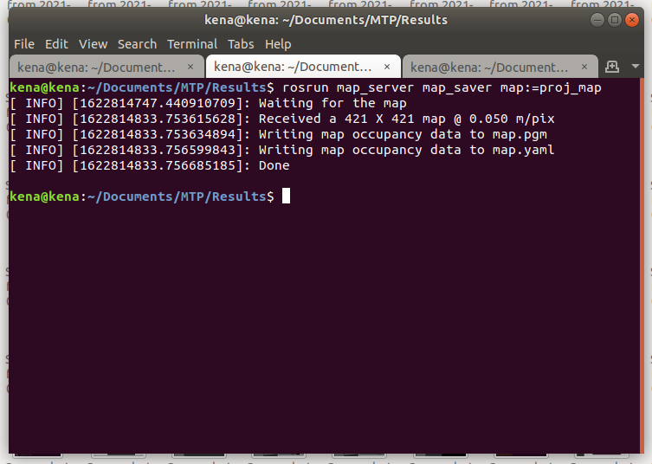

Now, you can find 2D map files i.e, map.pgm and map.yaml in the same directory where you are now.

**Example is as shown below:**

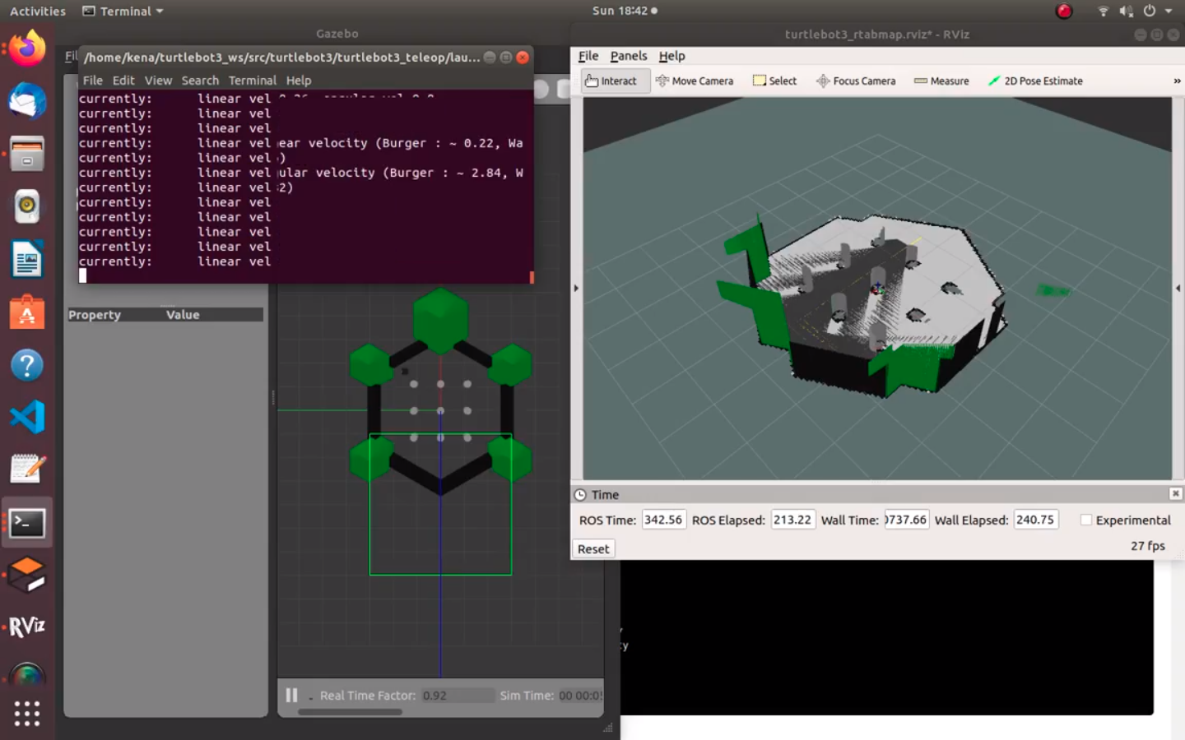

**References:**

<https://emanual.robotis.com/docs/en/platform/turtlebot3/overview/>

<https://github.com/ROBOTIS-GIT/turtlebot3>